$$A\frac{∂C}{∂t}=-UA\frac{∂C}{∂x}+\frac{∂}{∂x}\left(KA\frac{∂C}{∂x}\right)$$

Discrepancy ratio:

$$DR=\log{\frac{\hat{K}}{K}}$$

$$\overline{DR},RMS\left(DR\right)$$

|  |  |
| --- | --- |
| Seo, I. W., & Cheong, T. S. (1998). Predicting longitudinal dispersion coefficient in natural streams. *Journal of hydraulic engineering*, *124*(1), 25-32. |  |
| Kashefipour, S. M., & Falconer, R. A. (2002). Longitudinal dispersion coefficients in natural channels. *Water Research*, *36*(6), 1596-1608. |  |
| Disley, T., Gharabaghi, B., Mahboubi, A. A., & McBean, E. A. (2015). Predictive equation for longitudinal dispersion coefficient. *Hydrological processes*, *29*(2), 161-172. |  |
| Zeng, Y., & Huai, W. (2014). Estimation of longitudinal dispersion coefficient in rivers. *Journal of hydro-environment research*, *8*(1), 2-8. |  |
| Tayfur, G., & Singh, V. P. R. (2005). Predicting longitudinal dispersion coefficient in natural streams by artificial neural network. *Journal of Hydraulic Engineering*. | ANN model, dimensional data |

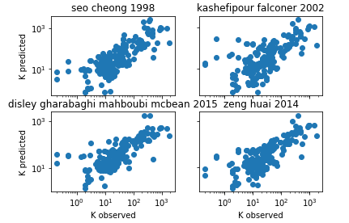

|  |  |
| --- | --- |
| h (m) | flow depth |
| K (m2/s) | longitudinal dispersion coefficient |
| R (m) | hydraulic radius |
| S | Slope of energy gradient or bed slope |
| U (m/s) | cross-sectional average velocity |
| U* (m/s) | shear velocity |
| W (m) | channel width |
| C (mg/L) | cross-sectional average concentration |
| A (m2) | flow cross-sectional area |
| x (m) | longitudinal coordinate |